**Predictive modelling with linear regression**

**Lego Set Dataset**

**Student Name: -** Niravkumar Purohit

**Student ID: -** (8923245)

**Subject: -** Multivariate Statistics  
Subject Code:- Stat8030

**Professor:** Bip Thapa

Index

Introduction …………………………………………………………………………3

Gathering Data………………………………………………………………………3

Descriptive Analytics……………………………………………………….4

Initializing Model…………………………………………………………………...7

Diagnostics………………………………………………………………………….9

Model Selection …………………………………………………………………….11

Prediction & Summary………………………………………………………………11

Reference.……………………………………………………………………………12

Appendix…………………………………………………………………………….13

**INTRODUCTION**

This project aims to analyze a dataset containing information about Lego sets. The dataset includes various predictors such as set names, reviews, product IDs, countries, and more. The main objective is to build a regression model to predict the list price of lego set based on these variables. The dataset is obtained from Kaggle and by examining the data and applying regression analysis techniques, we can predict the list price of lego sets.

1. **Gathering Data**

To do the analysis the data set is gathered from Kaggle website and the name of the dataset is Lego sets. List prices (the dependent variable) and different predictors, including set names, customer reviews, product IDs, and nations, are all included in the data regarding Lego sets. The dataset is appropriate for regression analysis because it includes a quantitative response (list price) and a number of predictors.

Dependent Variable: list price,   
Independent Variables: Set Names, Review, Product id, country, etc.

|  |  |
| --- | --- |
| **Variable** | **Type** |
| prod_id | Categorical |
| piece_count | Numeric |
| play_star_rating | Numeric |
| num_reviews | Numeric |
| review_difficulty | Categorical |
| star_rating | Numeric |
| country | Categorical |
| Age | Categorical |
| List_price | Numerical |
| Prod_desc | Categorical |
| Val_star_ratings | Numerical |
| Theme_name | Categorical |
| Set_names | Categorical |

**Descriptive analytics**

The minimum, Q1, median, Q3 and maximum values of the variables are given below.

ages list_price num_reviews piece_count

Length:12261 Min. : 2.272 Min. : 1.00 Min. : 1.0

Class :character 1st Qu.: 19.990 1st Qu.: 2.00 1st Qu.: 97.0

Mode :character Median : 36.588 Median : 6.00 Median : 216.0

Mean : 65.142 Mean : 16.83 Mean : 493.4

3rd Qu.: 70.192 3rd Qu.: 13.00 3rd Qu.: 544.0

Max. :1104.870 Max. :367.00 Max. :7541.0

NA's :1620

play_star_rating prod_desc prod_id prod_long_desc

Min. :1.000 Length:12261 Min. : 630 Length:12261

1st Qu.:4.000 Class :character 1st Qu.: 21034 Class :character

Median :4.500 Mode :character Median : 42069 Mode :character

Mean :4.338 Mean : 59837

3rd Qu.:4.800 3rd Qu.: 70922

Max. :5.000 Max. :2000431

NA's :1775

review_difficulty set_name star_rating theme_name

Length:12261 Length:12261 Min. :1.800 Length:12261

Class :character Class :character 1st Qu.:4.300 Class :character

Mode :character Mode :character Median :4.700 Mode :character

Mean :4.514

3rd Qu.:5.000

Max. :5.000

NA's :1620

val_star_rating country

Min. :1.000 Length:12261

1st Qu.:4.000 Class :character

Median :4.300 Mode :character

Mean :4.229

3rd Qu.:4.700

Max. :5.000

NA's :1795

**Histogram**

This is the graphical representation of the list price having x as list price and y as frequency.

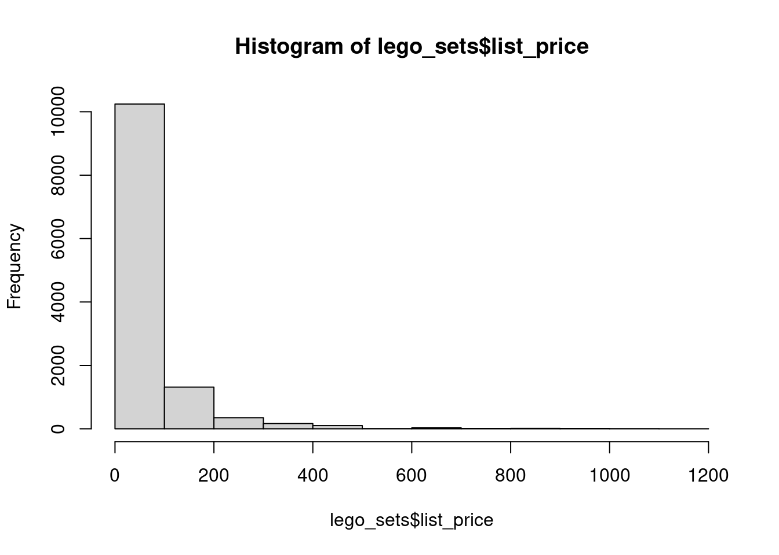

**Boxplot**

This is the boxplot representation of list price. It helps to detect the outliers. We have applied the log functions to make this boxplot.

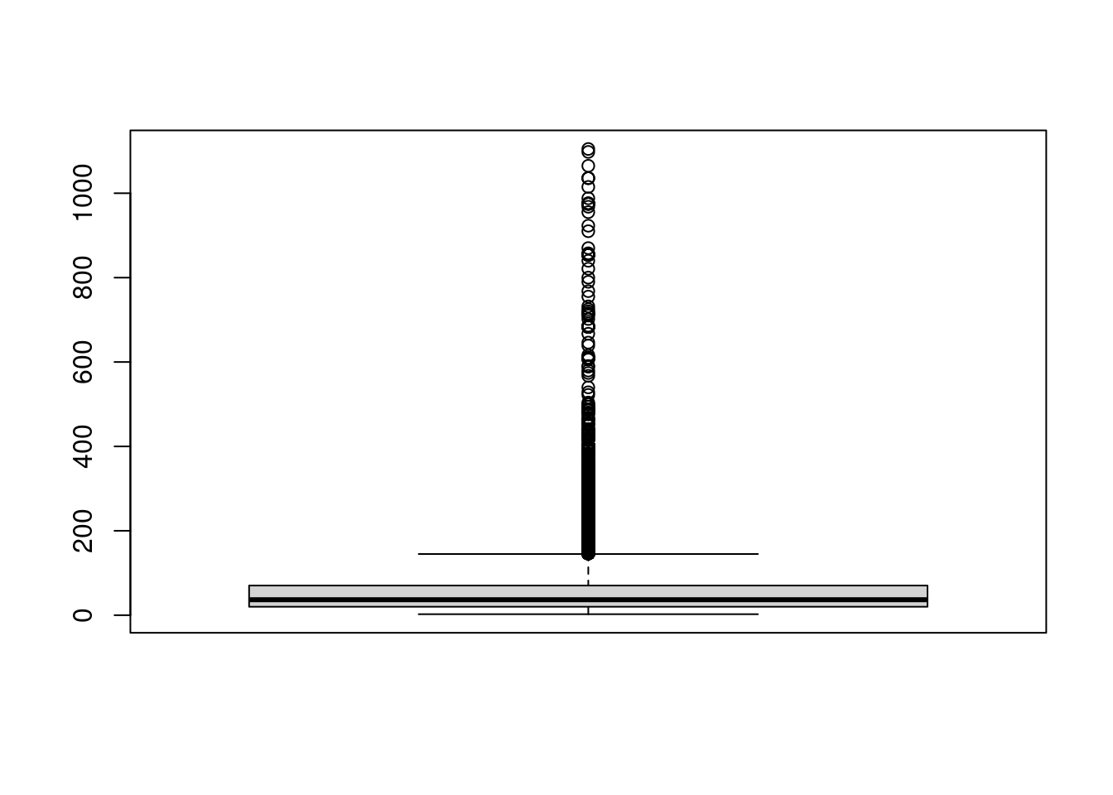

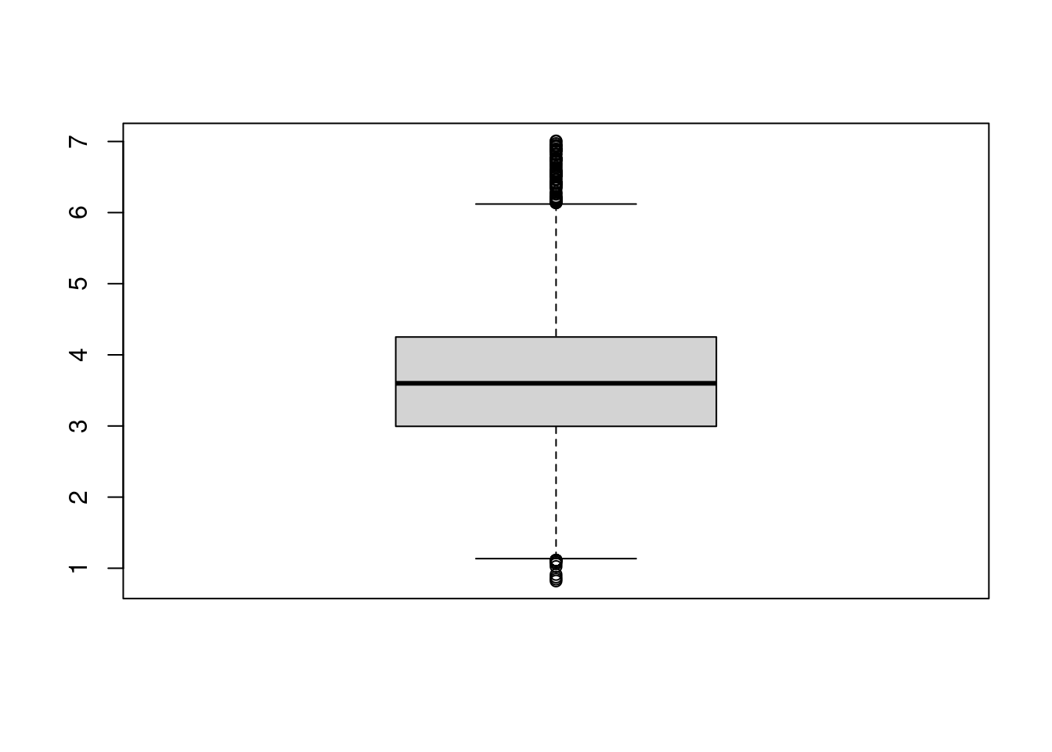

**Initializing Modelling**

In our first modelling, we took the following variables to create a model as they have high impact on the list price of Lego sets. The following predictors, in our opinion, are important:

* Set Names: The popularity or uniqueness of a Lego set might affect its price.
* Review: Higher-rated sets may command higher prices due to increased customer satisfaction.
* Product ID: Different product lines or categories could influence pricing.
* Country: Lego prices may vary across regions due to factors like local demand and distribution costs.

On the other hand, we do not choose factors like the Lego age, Prod description, theme name etc. These factors could add more noise to the model and are unlikely to have a direct effect on List price

The dataset was cleaned and prepared before we ran a linear regression model using the correct predictors. The regression's coefficients are shown in the table below:

list_price num_reviews piece_count play_star_rating prod_id

list_price 1.0000000 NA 0.8696299 NA 0.3886331

num_reviews NA 1 NA NA NA

piece_count 0.8696299 NA 1.0000000 NA 0.2177165

play_star_rating NA NA NA 1 NA

prod_id 0.3886331 NA 0.2177165 NA 1.0000000

star_rating NA NA NA NA NA

val_star_rating NA NA NA NA NA

star_rating val_star_rating

list_price NA NA

num_reviews NA NA

piece_count NA NA

play_star_rating NA NA

prod_id NA NA

star_rating 1 NA

val_star_rating NA 1

We have created the first model between list price and peace count. The adjusted R square value for this model is 0.7562 and RSE value is 45.41. On further we created one mode model with independent variables prod_ id, peace count, play star ratings, num reviews. On solving this we get adjusted Rsqure 0.8 which is better than model 1.

Residuals:

Min 1Q Median 3Q Max

-267.46 -14.38 -6.45 6.97 650.69

Coefficients:

Estimate Std. Error t value Pr(>|t|)

(Intercept) 1.732e+01 4.778e-01 36.26 <2e-16 ***

piece_count 9.691e-02 4.969e-04 195.03 <2e-16

Second Model: - In second model we have created a linear model between list price and other variables such as peace count, product id and play star ratings etc. There is an increase in adjusted R-squared value, which is a good sign for a model. The values are given below.

Residual standard error: 43.13 on 10155 degrees of freedom

(2076 observations deleted due to missingness)

Multiple R-squared: 0.8106, Adjusted R-squared: 0.8101

F-statistic: 1499 on 29 and 10155 DF, p-value: < 2.2e-16

**Diagnostics**

Now we will the diagnose both the linear model with the help of residual vs fitted graphs and QQplot 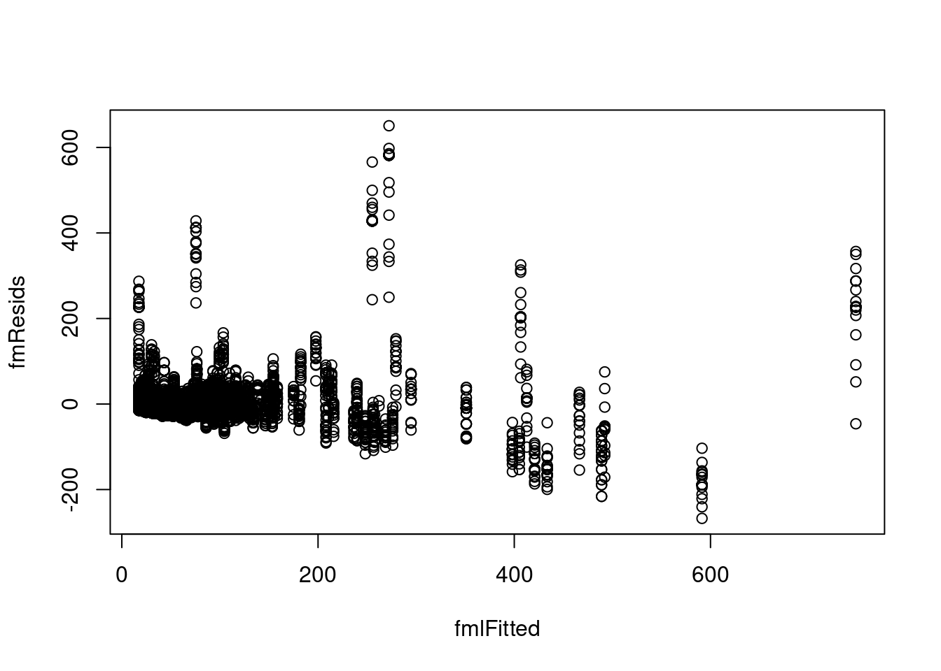

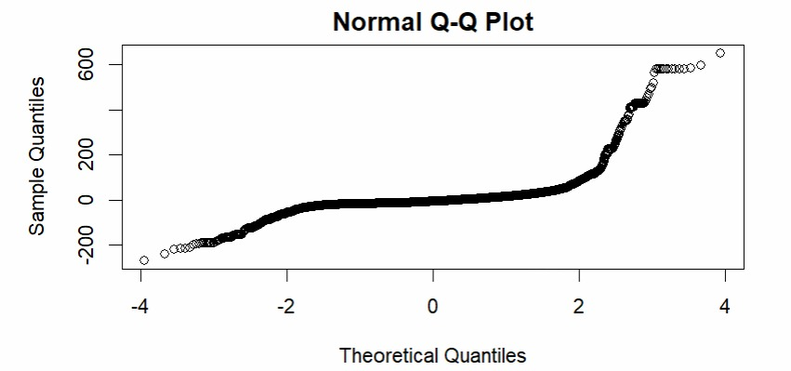

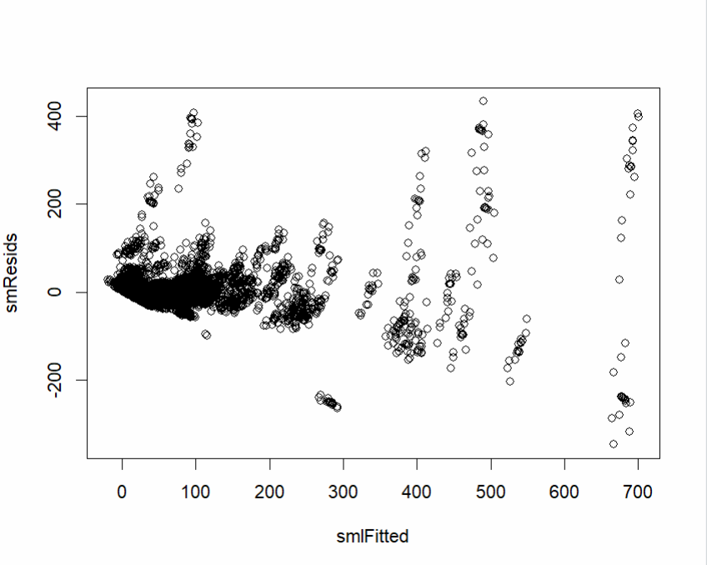

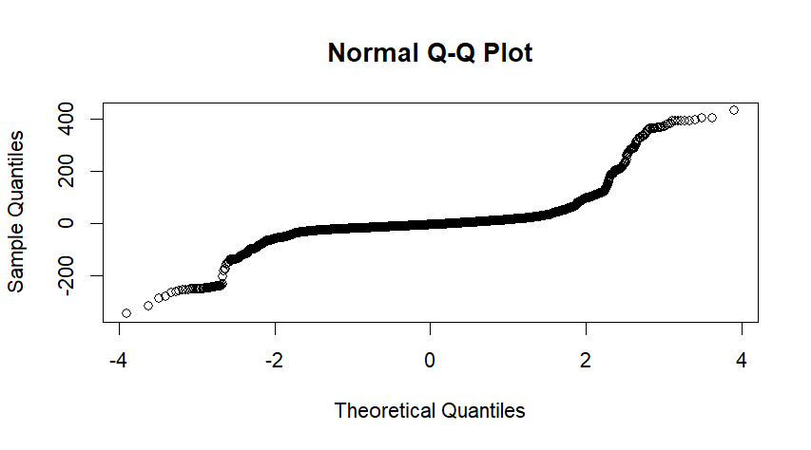

From the above diagram it is evident that the residuals are not normally distributed.

**Model Selection**

In this step, we have added polynomial terms such as squared terms, interaction terms to the model. However, none of the any additional terms improved the model. Therefore, we chose to stick with the initial linear regression model as it provided a good balance between simplicity and performance.  
  
We have selected smp model as the best model with the adjusted R-squre values 0.81, which is the highest value than other and predict the accurate value of list price.

**Prediction and Summary**

Now we have predicted list price value by assuming peace count 10, 20 and 30 within the confidence level 0.95 using first model on lego sets.

1 2 3

18.29346 19.26259 20.23173

fit lwr upr

1 18.29346 17.36180 19.22512

2 19.26259 18.33582 20.18937

3 20.23173 19.30977 21.15369

In summary, our regression analysis on the Lego Sets dataset revealed that set names, reviews, product IDs, and country are significant predictors of the list price of Lego sets. The initial linear regression model satisfied the assumptions of linearity, homoscedasticity, and normality. Non-linear terms were considered but did not contribute substantially to the model's performance. The selected model provides a reliable framework for predicting the list prices of Lego sets based on the given predictors.

**Reference**

Source: <https://www.kaggle.com/datasets/mterzolo/lego-sets>

Appendix

library(tidyverse)

library(MASS)

library(dplyr)

library(stargazer)

library(caret)

library(leaps)

library(ggplot2)

library(readr)

lego_sets <- read_csv("C:/Users/Hp/Downloads/archive (2)/lego_sets.csv")

View(lego_sets)

#descriptive analytics

str(lego_sets)

summary(lego_sets)

#histogram

hist(lego_sets$list_price)

boxplot(lego_sets$list_price,width = 0.7)

boxplot(log(lego_sets$list_price))

#correlations

numeric_data <- lego_sets[, sapply(lego_sets, is.numeric)]

cor_matrix <- cor(numeric_data)

print(cor_matrix)

cor(lego_sets$list_price,lego_sets$piece_count)

#first_model

attach(lego_sets)

fm<-lm(list_price~piece_count)

summary(fm)

sm<-lm(list_price~prod_id+piece_count+play_star_rating+num_reviews+review_difficulty+star_rating+country)

#sm <- lm(list_price ~ ., data = lego_sets)

summary(sm)

#diagnostic

fmResids <- fm$residuals

fmlFitted <- fm$fitted.value

plot(fmlFitted,fmResids)

dev.new(width = 10, height = 8)

par(mar = c(5, 5, 2, 2))

smResids <- sm$residuals

smlFitted <- sm$fitted.value

plot(smlFitted,smResids)

dev.new(width = 10, height = 8)

par(mar = c(5, 5, 2, 2))

qqnorm(fmResids)

qqnorm(smResids)

#extension

summary(sm)

smp<-lm(list_price~prod_id+I(prod_id^2)+piece_count+prod_id:play_star_rating+play_star_rating+num_reviews+review_difficulty+star_rating+country)

summary(smp)

#Feature_selection

step<-stepAIC(smp,direction= "forward",trace=FALSE)

step$anova

step1<-stepAIC(smp,direction= "backward",trace=FALSE)

step1$anova

smnp<-lm(list_price~prod_id+piece_count+prod_id:play_star_rating+play_star_rating+review_difficulty+star_rating+country)

summary(smnp)

summary(fm)

#prediction_model

piece_count_predictions <- data.frame(piece_count = c(10, 20, 30))

predict(fm,piece_count_predictions)

fm<-lm(list_price~piece_count)

piece_count_predictions <- data.frame(piece_count = c(10, 20, 30))

prediction_interval <- predict(fm, newdata = piece_count_predictions, interval = "confidence", level = 0.95)

prediction_interval